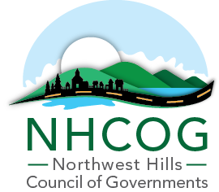

NOTICE OF SPECIAL MEETING
NHCOG EXECUTIVE COMMITTEE

DATE: JANUARY 15, 2026
TIME: 9:30AM – 11:00AM
LOCATION: IN-PERSON at NHCOG OFFICE, 355 Goshen Road, Litchfield, CT

AGENDA

Dan Jerram, Chairman | Mike Criss, Vice Chairman | Patrick Roy, Secretary | Tom Weik, Treasurer | Gordon Ridgeway, At-Large | Greg LaCava, At-Large

- Call to Order

- Workshop - discussion and direction on PA25-1 funding for Affordable Housing and MSW/MS4-Floodplain initiatives as it relates to FY26-27 budget preparation and overall strategic/programmatic planning.

- Approval of the May 20, 2025 Special Meeting Minutes (Attached)

- Adjournment

