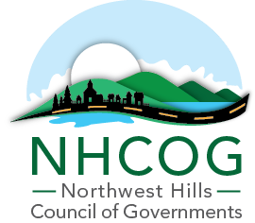

REQUEST FOR QUALIFICATIONS AND PROPOSALS (RFQ/RFP)

Northwest Hills Council of Governments (NHCOG)

Brownfield Area Revitalization (BAR) Planning Grant

Revitalization Along the Mad River – Winsted, Connecticut

RFQ/RFP: EDC 25 -12-01

Addendum #1

- Can you please confirm the property addresses and descriptions for properties No. 1 and 2 in Appendix A. The numbers on the map are reversed – see clips from Town GIS Map.

10 A Bridge Street
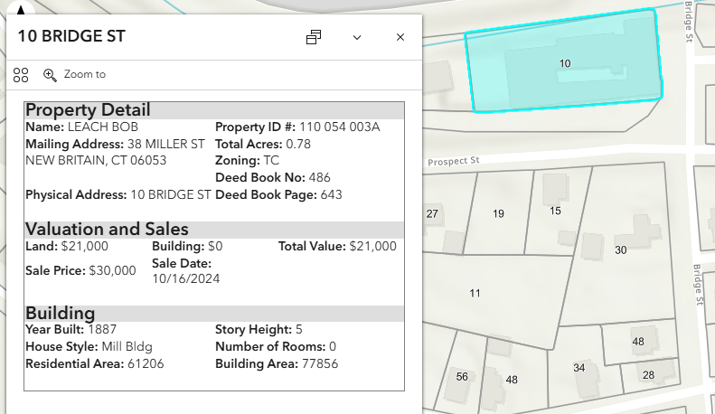

10B Bridge Street
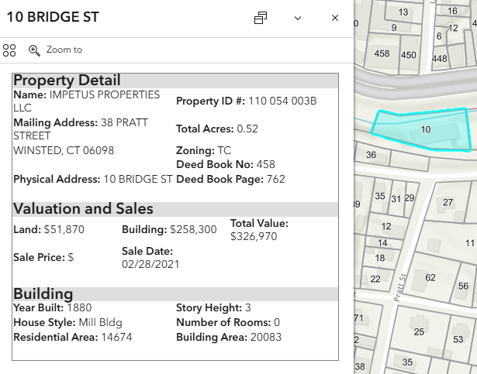

- Are there any existing environmental/structural/Hazardous Building Materials reports available for review for any of the properties prior to the submittal of a proposal?
The only report the NHCOG has is titled “Pin Factory Lofts – progress report” for 10A Bridge Street (attached). Property Owners may have other reports they would be willing to share, but at this time they have not shared any environmental reports.

- Are there existing site and/or area-wide plans available for review prior to the submittal of a proposal?
No

- For the purposes of Task 2, should we assume access will only initially be provided to the properties identified as such in Appendix A? Also, please confirm access to these properties (access agreements) will be managed by NHCOG?
At this time, that is a proper assumption. If other property owners choose to provide access at a later time, we can discuss how to proceed then. Yes, NHCOG will manage all access agreements.

- Can you confirm which properties are expected to have an environmental and/or structural review?
This is still unknown. For further clarification – as numbered on the map in appendix A:

Sites 1 (10B), 10 & 11 are NOT expected to have either environmental or structural review, but included for purposes of inclusion into master redevelopment plan

Sites 8 &9 pose significant potential for redevelopment and/or parking, but the property owners have not been responsive. If they continue to be unresponsive, it maybe desktop and street level review only. If they do provide access, there may be more in-depth review possible.

Sites 7,6, 4 & 3 Have potential, we are hoping to speak with property owners and to tour the sites, but it is not likely in-depth environmental or structural will be needed.

Site 2 (10A & 5) are expected to have the most detailed environmental and structural review.

However, there should be some flexibility built into the proposal to address needs as determined by Task 2.

- For Task 3, do you anticipate the scope to include preliminary structural analysis that may be identified as necessary during Task 2.
Yes, there is the potential that some preliminary structural analysis will be needed to help determine feasible uses that can be supported in that structure.

- There are several references to a survey. Has a survey of the study area already been completed? If so, will that survey be provided to the consultant and in what format?
NHCOG does not have any surveys on file. We will work with the Town to see what mapping they may have available, and the consultant may have to review land records to determine what mapping is available, if any.

- Should a title search for each property be included in our scope and cost? Or will this service be provided elsewhere?
A title search is not likely for each property. There is at least one instance of an easement, on one property, that may impact future development that will need to be researched.

- Are there any existing groundwater-monitoring wells on the sites included in the study area that are accessible and viable?
Not that we are aware of.

- Does NHCOG and/or Winchester have preliminary conceptual ideas/plans for proposed end uses of the properties?
There are no official conceptual ideas or plans on paper.

- Will NHCOG/Town staff support outreach efforts (meeting logistics, promotion, printing/mailing)?
NHCOG / Town Staff will support outreach efforts in as far as scheduling meeting locations, sharing on websites and social media and making 8.5X11 copies, if needed.

The consultant should be prepared to create all materials for the meetings, help determine the schedule and format of the meeting and lead the discussion during the meetings.

- Is there a specific number of public meetings, stakeholder discussions, or engagement events envisioned?
No, but it is expected that a large portion of the public outreach will be individual and small group discussions. However, it is important that we have community-wide support for this plan; therefore, more inclusive public meetings will also be necessary.

- For the cost proposal, will lump sum by task be sufficient?
Yes. If you feel its helpful to break down the tasks to sub-tasks in order to express the scope of work, that would acceptable too.

- Do you have any existing environmental reports for any of the properties in the study area?
The only report the NHCOG has is titled “Pin Factory Lofts – progress report” for 10A Bridge Street (attached). Property Owners may have other reports they would be willing to share, but at this time they have not shared any environmental/structual reports.

- The RFP mentions that on-site assessment cannot make up more than 25% of the budget. Task 3 identifies new data collection as a scope item, including environmental data. Are you specifically requesting on-site testing on any of the parcels? If yes, which parcels?
At this time we are not specifically requesting on-site testing of any parcel in particular. However, if during the process of this study environmental or structural testing is necessary to determine feasibility of future use and/or development limited testing can be done. See Q5 of this addendum for further clarification.

- One of the stated objectives of the project is “coordinated brownfield remediation.” Is development of an area-wide Remedial Action Plan to be included in the scope of work?
An Area-wide RAP is not expected. We expect any plans to still be conceptual, but developed to the point that we can say they are likely feasible. While we don’t expect full RAPs to be developed, remediation considerations, such as Land Use Restrictions, should be considered as part of “feasibility”

- Does the Town have any projects planned for the site area?
No
- Is the Town aware of any private development projects proposed within the project site area?
No
- Is there an expectation for the timeline/duration of the project?
A 12-month timeline would be considered appropriate, but more or less time will be considered. Proposals should include a proposed timeline, which will be considered as part of the selection criteria.

- How many TAC meetings are expected? Is it expected that all TAC meetings would be in-person?
Not all TAC meetings need to be in person, all or some can be virtual. TAC meetings should be only at key points in the process, where buy in from all property owners and the Town is necessary. These are not intended to occur on a regular basis. This may vary based on approach; therefore, the consultant should indicate how many times they recommend the TAC meet.
- In addition to the direct stakeholder meetings, how many public meetings/information sessions are anticipated?
We do not have an exact number in mind, we are hoping the consultant will help us develop an appropriate outreach plan; however, we expected that a large portion of the public outreach will be individual and small group discussions. Refer to Question 12 of this addendum.

- Have any Phase I or Phase II (subsurface investigation) environmental site assessments (ESAs) of any of the subject parcels been previously completed? Unknown, NHCOG does not have any environmental reports If so, are those reports available from NHCOG or the property owners? No Additionally, for properties where Appendix A states that no new environmental is expected – does that mean that some level of environmental review has been done? No, it is assumed that either they are not considered brownfields, or the property owner will not give access.
- Have any hazardous building materials assessments (HBMAs), including lead, asbestos, and/or hazardous equipment or fixtures of any of the buildings been completed? Unknown, NHCOG does not have any HBMAs And if so, are those reports available from NHCOG or the property owners? No
- At the top of Appendix A, the text states, “The following table summarizes all properties within the BAR Program Planning Area. Sites marked with an asterisk (*) are anticipated to undergo structural and/or environmental review as part of this study.” An asterisk appears for 10A and 10B Bridge Street and 35 Willow Street. However, the comments for 10B Bridge Street note, “No new environmental/structural review expected.” Could you please clarify whether environmental and structural reviews are required for 10B Bridge Street?
The building is largely occupied with the exception of the basement. Some consideration as to what uses may be suitable for the 3rd floor is expected. Also, some site development may need to be considered. The property owner does not want any additional environmental testing done without prior authorization, so we are not proposing any assessment; however, existing site conditions should be examined to determine feasibility of future uses or development.
- For several properties listed in Appendix A, the required level of environmental and structural review is not yet known. For example, for 45 and 8 Willow Street, Appendix A notes that these reviews should be completed if access is granted. In addition, 38 Depot Street is listed as having “potential environmental review.” How would you like us to reflect this in the scope given the uncertainty? We will be open to several options, but in general this task should have some funding earmarked, but with enough flexibility to adjust as needed. We expect this will be an iterative process, and don’t expect concrete scope of work at this time. For instance, should we assume access will be granted and include the reviews in Task 2, or defer them to Task 3 with a discrete budget for additional study that would be initiated only once the level of review is confirmed? Alternatively, we could break these out as separate, “if needed or access granted” tasks? Both options are acceptable.

- Can you provide guidance on the intent for the structural review, for example, would it be to determine if the buildings reviewed are salvageable for re-use, with “conceptual” repair recommendations. It is our understanding that a floor load rating analysis to determine allowable loading of the buildings would be beyond the scope of this project
You are correct, structural analysis is intended more for feasibility purposes, for example if there are support beams every 15’, it would not be a likely recommendation that the proposed use require large open floor plans. If there is no egress from a third floor, it would not be likely housing is recommended, etc….
Additionally, existing conditions may impact financial feasibility, these conditions should be noted, along with recommended future assessments to help leverage assessment funding as appropriate.
- Would the 25% budget cap on ESAs apply for environmental study work that is conducted for the area but is not attached to any particular site (as part of a Phase I or Phase II ESA)?
DECD limits the amount of grant funds to be used on assessment to 25% of the total project, but does not regulate where and how we disperse those funds.

