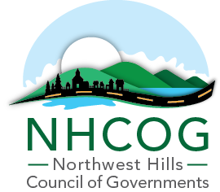

NOTICE OF SPECIAL MEETING OF THE EXECUTIVE COMMITTEE

DATE: July 23, 2024
TIME: 3:00PM
Virtual Meeting

https://nam11.safelinks.protection.outlook.com/?url=https%3A%2F%2Fus02web.zoom.us%2Fj%2F88042911198%3Fpwd%3DRdiCcYcoQOjNyIfLAN2FdUIBi9baqZ.1&data=05%7C02%7Crphillips%40northwesthillscog.org%7C54a60bcba56f4485181908dca74e1b68%7Cad411cad4d424a40a9b29204886fb338%7C0%7C0%7C638569201118743601%7CUnknown%7CTWFpbGZsb3d8eyJWIjoiMC4wLjAwMDAiLCJQIjoiV2luMzIiLCJBTiI6Ik1haWwiLCJXVCI6Mn0%3D%7C0%7C%7C%7C&sdata=I5zAFmIRGOnwAraKvi77r3fl%2Bh%2FVQZZdsg0a4Ln3Sjs%3D&reserved=0

Meeting ID: 880 4291 1198
Passcode: 863283

AGENDA
(Dan Jerram, Chairman; Mike Criss, Vice Chairman; Patrick Roy, Secretary; Tom Weik, Treasurer, Gordon Ridgeway and Elinor Carbone, At-Large)

- Call to Order

- Legal Services for MSW and Recycling in the NHCOG region.

- Approval of the May 6, 2024 and June 6, 2024 Special Meeting Minutes

- Adjournment

