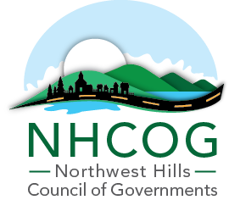
Northwest Hills Council of Governments
REQUEST FOR PROPOSALS
Meadow Street, Winsted CT
Environmental Assessment Services
RFP: EDC 05-2025-02

The Northwest Hills Council of Governments (NHCOG) is issuing this Request for Proposal (RFP) to awarded firms on the State of CT Department of Administrative Services contract #18PSX0153, to retain a consultant or consulting team to complete environmental investigations and site planning activities for a 8.1 acre parcel, 41 Medow Street (Assessor’s Map: 106/095/013-14) and 2 vacant lots 1.4 acres, known as 3 Medow Street (Assessor’s Map: 106/95/012 & 110/095/009A).
41 Meadow Street is an historic industrial site, privately owned and is comprised of multiple buildings.
3 Meadow Street and Lot 1 will both be referenced as "3 Meadow Street" as the lots are vacant lots, both owned by the Town of Winchester and will be treated as one lot for redevelopment purposes.

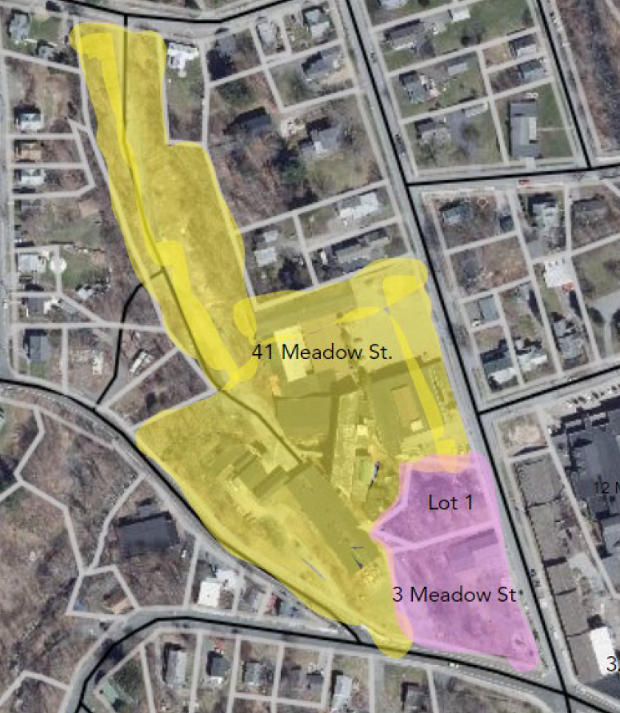
NHCOG was awarded a Brownfield Assessmenet Only Grant from the Connecticut Department of Economic and Community Development to conduct environmental assessment and planning activities to identify the appropriate re-use of 41 Meadow Street and guide municipal parking lot improvements at the vacant lots.

There will not be a public opening of this bid

MBE’s, WBE’s and SBE’s ARE ENCOURAGED TO APPLY
AN AFFIRMATIVE ACTION/EQUAL OPPORTUNITY EMPLOYER

The Respondent’s submittal shall include one (1) original and three (3) exact copies and shall be delivered or mailed to the NHCOG, 355 Goshen Rd, PO BOX 832, Litchfield CT 06759 during normal office hours by no later than 11:00 AM, July 8, 2025. Submittals received after this date and time will not be accepted. Sealed envelope(s) should be clearly marked: ”RFP #EDC 05-2025-02: Meadow Street, Winsted – Environmental Assessment Services”. In the case where the office is closed for weather related or some other emergency related circumstance, then submittals shall be due the next day when Office reopens for business, no later than 11:00 AM on that day. Fax or emailed submissions will not be accepted.

All questions must be submitted by June 27, 2025 by noon. Questions must be submitted by email to the Director of Economic and Community Developmet Direct Rista Malanca at rmalanca@nhcogct.gov . All questions determined to be of interest to all prospective firms will be answered in writing by an addendum, which will be posted on the NHCOG and state web sites. It is the responsibility of potential bidders to check these websites for addendum(s). Interested firms should check the website 48 hours before the closing date.

This RFP does not commit the NHCOG to select any Respondent or enter into any contract agreement. The NHCOG reserves the right to accept or reject any or all RFP’s; to waive any informalities, and if it is deemed to be in the public’s best interest, to enter directly into negotiations with one or more Respondents based on responses to the RFP, to request additional information from some or all Respondents. The Northwest Hills Council of Governments reserves the right or to accept any proposal deemed in the best interests of the NHCOG.
The NHCOG will not be liable for any costs incurred by a firm in the preparation or submission of a proposal.

The information provided herein is not intended to and shall not bind the NHCOG to any of the statements or assumptions set forth herein.

Responses must set forth accurate and complete information for each of the items listed below. At the NHCOG’s discretion, failure to do so could result in disqualification.

Submittal Requirements
In your submittal, NHCOG is requesting the following:
- A cover letter signed by the primary firm, binding the firm to all of the commitments made in the proposal. This shall include the prime consultant contact information and all subconsultants. Note: NHCOG will contract with the primary consultant/firm of the team and all others will be considered subconsultants under the executed agreement
- A description of the project team’s core personnel, including resumes, relevant projects and firm’s brochure
- Detailed Scope of Work
- Hourly rates and expense schedule
- Demonstrate abilty to meet the Proposed timeline
- The name(s), business address, phone number, e-mail address of firms and individuals proposed to participate in all tasks identified in the scope of work.
- At least 3 Professional References
- Proof of Insurance and Liability (See Appendix A)
- Required Forms - Non-Collusion Affidavit, (Appendix C) and any additional forms NHCOG may require (Appendix B).
- Fee Proposal and hourly rates and expense schedule must include a statement that the fees (and scope) remain valid for a period of at least ninety (90) days from the date of its submission. If selected, fee schedule should remain in place for the entire duration of the project.

Schedule
Applicants are to respond to this request by 11am on July 8, 2025
All questions must be sent in by 12:00 noon on June 27, 2025
The Selection Committee, at its discretion, may develop a short list of candidates based on the stated selection criteria to interview for the project. The short listed firms will be notified via email and will be provide sufficient notice of the interview date and time.
A decision is expected in early July with project kick off to start immediately and completed within 6-8 months.
The successful Respondent will be expected to be able to commence services as soon as possible upon award, as determined by the NHCOG. Any contract entered into by the NHCOG, and the successful bidder shall provide that the NHCOG may terminate the contract upon thirty (30) days’ notice to the bidder.

Selection Criteria

The selection committee will evaluate the Respondents based on the following criteria:
- Experience of personnel to be assigned to the project team on similar brownfield and redevelopment projects
- Current workload and demonstrated capacity to meet schedule. Ability to provide the services within proposed project schedule time constraints
- Consultant’s awareness of project issues, opportunities and constraints
- Hourly fees and Fee Proposal
- Responsiveness to the Proposed Scope of Work and Respondent’s understanding of the Project

Overview / Purpose

The Town has seen increased demand for small manufacturing and fabricating. 41 Meadow Street is an ideal location to meet the needs of the Community. Due to its proximity to 41 Meadow Street and 32 Lake Street (another former industrial site, now home to Edge Works Axe house and Little Red Barn Brewers) 3 Meadow Street will be an improved municipal parking lot to support the redevelopment of these sites.

In addition to environmental and structural assessments, conceptual design will be conducted to encourage future redevelopment of both sites. Planning and design cannot exceed more than 20% of the project.

41 Meadow Street

41 Meadow Street's industrial heritage dates back to 1852; however, it is mostly known as the home to The Fitzgerald Manufacturing Co. which was established in 1906 by a Torrington machinist named Patrick J. Fitzgerald to produce metal gaskets for early automobiles, a product that needed to be replaced often and was in growing demand. While automotive gaskets remained in their production line for much of the company’s existence, it also produced electrical household appliances, such as electric ranges, toasters, percolators and clothes irons, under the name Son-Chief Electrics Inc. In 1931, Fitzgerald Mfg. Co. employed 200 men at the site, and an additional 800 at the main factory in Torrington. With the widespread use of synthetic materials to produce gaskets and the general decline of the metals industry, the Fitzgerald Mfg. Co. was sold in the 1970s.

Son-Chief Electrics operated at this location through the early 2000’s dissolving as a company in 2013. The building was then purchased by Meadow Street Commons Winsted, LLC (current owner). A portion of the building is leased to various light manufacturing and storage businesses; however it is still underutilized. Approximately only 30% of the buildings are occupied, the remainer of the property remains unoccupied due to environmental concerns, structural conditions and/or local regulation restrictions.

A Phase I ESA was completed on 7/13/2013. There has been no change in condition since 2013. In 2008 subsurface soil and groundwater investigation was conducted for a previous potential owner. The owner only has hard copies of both reports. Reports only are included, but attachments, maps, figures and tables can be provided as necessary. This site is considered an establishment under the Transfer Act.
Link to both reports (Phase I ESA and Subsurface Soil/Ground Water Quality) along with most recent Assessor’s Card.

The existing environmental conditions of this site have prohibited further build-out to accommodate new spaces for businesses to lease. Additional environmental assessment is necessary to determine how an adaptive reuse project can be built within the existing footprint and what environmental restrictions will be necessary. Along with redevelopment plans, a remedial action plan to support that development must be developed to determine feasibility and to secure the necessary capital stack for both remediation and development purposes.

Additionally, a portion of these funds will be used for planning and design purposes, to determine compliance with local regulations and codes, develop a feasible redevelopment concept(s) and additional funding sources to support redevelopment.

3 Meadow Street

3 Meadow Street had various uses over the years, last being an Autobody repair shop. The Town of Winchester acquired this property through foreclosure on blight liens. To eliminate the blighted conditions, the Town razed the buildings and did some minor grading; however, they have been unable to do any further work on the property due to potential contamination of the site

This parcel is informally being used for parking for local businesses, but there are no improvements or maintenance of this property. The Town wishes to make this an improved municipal parking lot to support this redevelopment project, along with other development in this neighborhood.

Improvements are likely to include paving, lighting and landscaping; however, if feasible parking structure may be considered. Assessment is needed to determine existing contamination before improvements can be made.

No environmental assessment has been done for 3 Meadow Street.

Summary Outline of Scope of Services

The NHCOG is accepting a statement of proposal with itemized cost estimates from environmental consulting firms who are listed on the State of CT Department of Administrative Services Contract number 18PSX0153. Since this proposal is multi-disciplined, bidders should elaborate on how they will address the planning and design aspects of this proposal, either in-house or by partnering with a sub-contractor(s).

Scope of Work: 41 Meadow Street
- Conceptual Redevelopment Plan*: This plan will be an iterative process, to inform targeted exploratory testing and then refined by environmental and structural conditions. The property owner is interested in attracting multiple tenants, such as light manufacturing, fabricating, warehouse, and/or office. The Redevelopment plan should include, at a minimum, a list of potential uses suitable for environmental conditions, compliance with local codes and regulations (zoning, wetlands, floodplain, fire, building) and a conceptual layout of how the building can be subdivided to support multiple tenants, including shared/common spaces & private shop/office spaces.

- Preliminary building conditions analysis* should include, at a minimum, structural analysis/review to determine load rating for floors and potential layout, access & egress review, ADA Accessibility, utility condition/functionality and necessary code improvements to support conceptual redevelopment plan.
*This information will be used to develop a feasible redevelopment plan and inform the RAP
- Environmental Site Assessment Phase I / Data Gap analysis: Review existing data and Identify data gaps to inform Phase II/III

- Environmental Site Assessment Phase II / III: Appropriate soil testing to determine extent of contamination and remediation options to support redevelopment plan.

- Limited Hazardous Building Materials Assessment: Building materials will be inspected and tested for the presence of asbestos and lead paint, and an inventory of suspect PCB-containing materials will be compiled to determine the presence of such materials and the potential costs associated with abatement and disposal of such materials. Note: Analytical testing for the presence of PCBs in building materials will not be conducted unless expressly authorized by the property owner. The consultant will not conduct any destructive testing unless expressly authorized by the property owner.

- Remedial Action Plan (RAP) and cost estimates: RAP should be consistent with conceptual redevelopment plan and provide cost estimates for both soil remediation and Hazardous Building Materials abatement.

- Assistance with entering the appropriate Voluntary Remediation Programs (VRP) offered by CT Department of Environmental and Energy Protection (DEEP)

Scope of Work: Meadow Street
- Environmental Site Assessment Phase I: A standard Phase I will be conducted to help guide Phase II soil testing.

- Environmental Site Assessments Phase II / III: Sufficient testing to identify the extent of contamination on site.

- Develop a conceptual Site Plan to include access, parking layout, lighting and landscaped areas.

- Remedial Action Plan (RAP) and cost estimates for the development of a municipal parking lot. RAP should take into consideration a conceptual site plan, including necessary utility corridors and landscaped areas.

- Assistance with entering the appropriate Voluntary Remediation Programs (VRP) offered by CT Department of Environmental and Energy Protection (DEEP)

Note: Environmental investigations and remediation under DECD’s Brownfield program must follow the Connecticut Site Characterization Guidance Document (effective September 2007, revised December 2010); the Connecticut Remediation Standard Regulations Sections 22a- 133k-1 through 22a-133k-3 of the regulations of Connecticut State Agencies (RCSA) (adopted January 1, 1996 and amended on June 27, 2013 and February 16, 2021); and ASTM Standard Practice for Environmental Site Assessments E-1527-21; as well as all pertinent State and Federal regulations.

APPENDIX A
NHCOG
REQUEST FOR PROPOSALS
Meadow Street, Winsted – Environmental Assessment Services

INSURANCE REQUIREMENTS

Certificate of Insurance: All insurance policies must include a Waiver of Subrogation whereby the insured waives its right to subrogate against the Northwest Hills Council of Governments and the State of CT, its subsidiaries, employees, volunteers, directors and officers. Proof of proper insurance coverage, Workers Compensation Insurance, Liability and Property damage, and Vehicle Insurance shall be filed with the Northwest Hills Council of Governments within 10 days after the award of the bid. The Certificate of Insurance must name the Northwest Hills Council of Governments 355 Goshen Rd, Litchfield, CT, and the State of CT, their subsidiaries, employees, volunteers, directors & officers as the “Additional Insured” and filed with the Purchasing Agent prior to commencement of work. Renewal Certificates of Insurance must be mailed to the Purchasing Agent 10 days prior to the expiration of the required coverage.

NON-DISCRIMINATION
The respondent agrees and warrants that in the performance of the contract pursuant to this solicitation he/she will not discriminate or permit discrimination against any person or group of persons on the grounds of sex, race, color, religion, age, marital status, ancestry, national origin, past history of mental disorder, mental retardation or physical disability or other basis in any manner prohibited by the laws of the United States, the State of Connecticut or the Northwest Hills Council of Governments

INDEMNIFICATION
To the fullest extent permitted by law, the Firm shall indemnify and hold harmless the Northwest Hills and their respective consultants, agents, and employees from and against all claims, damages, losses and expenses, direct, indirect or consequential (including but not limited to fees and charges of attorneys and other professionals and court and arbitration costs) arising out of or resulting from the performance of the Firm’s work, provided that such claim, damage, loss or expense is caused in whole or in part by any negligent act or omission by the Firm, or breach of its obligations herein or by any person or organization directly or indirectly employed or engaged by the Firm to perform or furnish services, or anyone for whose acts the Firm may be liable, regardless of whether or not it is caused in part by a party indemnified hereunder.
As to any and all claims against the Northwest Hills Council of Governments or any of its consultants, agents or employees by any employee of Firm, by any person or organization directly or indirectly employed by Firm to perform or furnish any of the work, or by anyone for whose acts Firm may be liable, the indemnification obligation under this section shall not be limited in any way by any limitation on the amount of type of damages, compensation or benefits payable by or for Firm under worker’s or workman’s compensation acts, disability benefit acts or other employee benefit acts.

APPENDIX B
NHCOG
REQUEST FOR PROPOSALS
Meadow Street, Winsted – Environmental Assessment Services

Acceptance of Terms of this Agreement
Name of Proposer: _____________________________________________________________________
Contact Person: ________________________________________________________________________
Address: _____________________________________________________________________________
City/State/Zip: _________________________________________________________________________

Telephone: ___________________________________________ Fax: ___________________________

E-mail: _______________________________________________________________________________

Authorized Signature_________________________________________ Title: _______________________
Name Printed: ____________________________________________________ Date: ________________

Federal Tax Identification Number: (FEIN) ___________________________________________________
It is agreed by the above signed proposer that the signature and submission of this proposal represents the proposer’s acceptance of all terms, conditions, and requirements of the proposal specifications, and, if awarded, the proposal will represent the agreement between the parties.

The proposer agrees that the cost of any work performed, materials furnished, services provided, or expenses incurred, which are not specifically delineated in the proposal documents, but which are incidental to the scope, intent, and completion of this contract, shall be deemed to have been included in the prices for the various items scheduled.

_________________________________________________
Authorized Signature

APPENDIX C
NHCOG
REQUEST FOR PROPOSALS
Meadow Street, Winsted – Environmental Assessment Services
NON-COLLUSION AFFIDAVIT
STATE OF ___________________COUNTY OF ____________________________
I, _________________________________________, being first duly sworn, deposes and says that:
1. I am ____________________________________________ of____________________________________________, the
Bidder that has submitted the attached Bid for “_______________________________________”.
2. I am fully informed respecting the preparation and contents of the attached Bid and of all pertinent circumstances respecting such bid;
3. Such Bid is genuine and is not a collusive or sham Bid;
4. Neither the said Bidder nor any of its officers, partners, owners, agents, representatives, employees or parties of interest, including this affiant, has in any way colluded, conspired, connived or agreed directly or indirectly with any other Bidder, firm or person to submit a collusive or sham Bid in connection with such Contract, for which the attached Bid has been submitted nor has it in any manner, directly or indirectly, sought by agreement or collusion or communication or conference with any other Bidder, firm or person to fix the price or prices in the attached Bid or of any other Bidder, or to fix any overhead, profit or cost element of the Bid price or the price of any Bidder, or to secure through any collusion, conspiracy, connivance or unlawful agreement any advantage against the Northwest Hills Council of Governments or any person interested in the proposed Contract; and
5. The price or prices quoted in the attached Bid are fair and proper and are not tainted by any collusion, conspiracy, connivance or unlawful agreement on the part of the Bidder or any of its agents, representatives, owners, employees, or parties in interest, including this affiant.
(Printed) ___________________________________
(Signed) __________________________________

(Title) _____________________________________

Subscribed and sworn to before this________ day of ______________, 20__________.
________________________________________
Notary Public Printed
________________________________________
Notary Public Signature

My Commission Expires __
___________________________ (Notary Seal)
NOTE: Documents must be signed before and sealed by a Notary Public. Only documents bearing a notary seal will be accepted.

