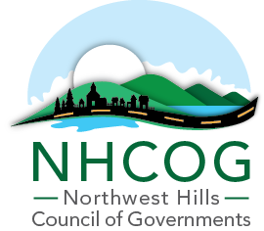

NOTICE OF SPECIAL MEETING
NHCOG EXECUTIVE COMMITTEE

DATE: APRIL 24, 2026
TIME: 11:00AM – 12:00PM
LOCATION: REMOTE ONLY (Link below)

Microsoft Teams meeting
Join: https://teams.microsoft.com/meet/27365640115471?p=FTQSKdOuFIOCNOqouf
Meeting ID: 273 656 401 154 71
Passcode: YR78Sv6c

AGENDA

Dan Jerram, Chairman | Mike Criss, Vice Chairman | Patrick Roy, Secretary | Tom Weik, Treasurer | Gordon Ridgeway, At-Large | Greg LaCava, At-Large

- Call to Order

- Public Comment / Member Concerns

- Approval of the February 24, 2026 Special Meeting Minutes (Attached)

- FY26-27 Draft Budget Presentation – Review and potential recommendation to the full NHCOG board. (Attached)

- Adjournment

