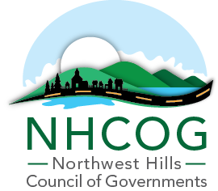

NOTICE OF SPECIAL MEETING
NHCOG EXECUTIVE COMMITTEE

DATE: JANUARY 23, 2026
TIME: 11:30AM – 1:00PM
LOCATION: ZOOM ONLY (Link below)

AGENDA

Dan Jerram, Chairman | Mike Criss, Vice Chairman | Patrick Roy, Secretary | Tom Weik, Treasurer | Gordon Ridgeway, At-Large | Greg LaCava, At-Large

- Call to Order

- Continued Workshop - discussion and direction on PA25-1 funding for Affordable Housing and MSW/MS4-Floodplain initiatives as it relates to FY26-27 budget preparation and overall strategic/programmatic planning.

- Approval of the May 20, 2025 and January 15, 2026 Special Meeting Minutes (Attached)

- Adjournment

Join Zoom Meeting
https://us02web.zoom.us/j/87423192575?pwd=iA8AFWWHxcCNXNzuaQxRz3jzOTCVod.1

Meeting ID: 874 2319 2575
Passcode: 555101

Call-in Option: 1-305-224-1968

