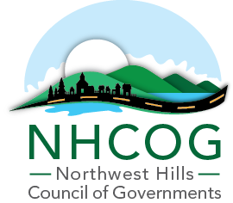

NOTICE OF SPECIAL MEETING OF THE EXECUTIVE COMMITTEE

DATE: June 6, 2024
TIME: 2:00pm
Virtual Meeting

https://us02web.zoom.us/j/88567978489?pwd=kfERis4rBiOP7N54bwbEkKkTRbOtrS.1

Meeting ID 885 6797 8489 Passcode: 339978

AGENDA
(Dan Jerram, Chairman; Mike Criss, Vice Chairman; Patrick Roy, Secretary; Tom Weik, Treasurer, Gordon Ridgeway and Elinor Carbone, At-Large)

- Call to Order

- Draft FY24-25 NHCOG Annual Budget Review and Endorsement for Board Approval

- Review of changes to the By-Laws and Policies & Procedures

- Approval of the May 6, 2024 Special Meeting Minutes

- Adjournment

